Citizenship and Ideology:

To what extent should my actions as a citizen be shaped by an ideology?

A citizen lives in and is a member of a country
A citizen votes
A citizen has certain responsibilities like usually obeying laws and paying taxes
A citizen also has certain rights i.e. freedom of speech, arbitrary arrest

Values associated with citizenship include:

Advocacy; political participation; rights, roles, responsibility.

Key Question: What determines citizenship?

“Jus soli”(right of soil) or “Jus sanguinis” (right of blood)

Rights vs responsibility
Freedom of …. Rule of Law
equality/mobility rights Expression and Obey
Help others
Pay Taxes
Care and Protect Heritage
Care and Protect Environment
Eliminate discrimination

To what extent do citizens have a right/role/responsibility to take action?
Liberation Movements

Apartheid in South Africa 1948-1994
Apartheid in south Africa was a set of laws which allowed the ruling white minority in south africa to segregate, exploit and terrorize the majority: African, Asians, Coloured (Mix race). Under these laws they were denied human and political rights. It dictated in the minutest detail how and where the black majority could live, work, die. First group to organize against Apartheid was African National Congress under the leadership of Nelson Mandela. It began as acts of civil disobedience but then turned violent. This included sit ins, nonviolent protests, boycotts and strikes. By 1960’s the movement was becoming violent and the world began to respond with boycotts of South African Products, Loans and embargos. Nelson Mandela was arrested in 1964 and was released in 1990. The Truth and Reconciliation Commission was appointed to travel throughout South Africa and honor the truth and reconcile the crimes of the past. Although now in South Africa only ½ of 18-24 yr olds are ready to vote and there is a high regard for consumer wealth, consumption and consumer goods, for the first time since Apartheid the black middle class is now bigger than the white.

1. Which of the following is not true of apartheid in South Africa?

a. while it was widely practiced, it was not actually law
b. it could be deemed as racism made law
c. the African National Congress fought against apartheid
d. The anti-apartheid movement started peacefully but later got violent

2. "Non-violence is not inaction. It is not discussion. It is not for the timid or weak...non-violence is hard work. It is the willingness to sacrifice. It is the patience to win." Which of the following would not be an example of this philosophy?

a. Boycotting businesses of those you disagree with
b. Organizing protests and sit-ins to publicize your cause
c. Staging strikes at places of business to protest policies
d. Kidnapping key figures in order to get attention for your cause

3. Which of the following is a major shift in South Africa since the end of apartheid?
a. Most whites have moved out of South Africa
b. The black middle class is larger than the white
c. Consumerism and desire for wealth has drastically decreased
d. 90% of youth are registered to vote

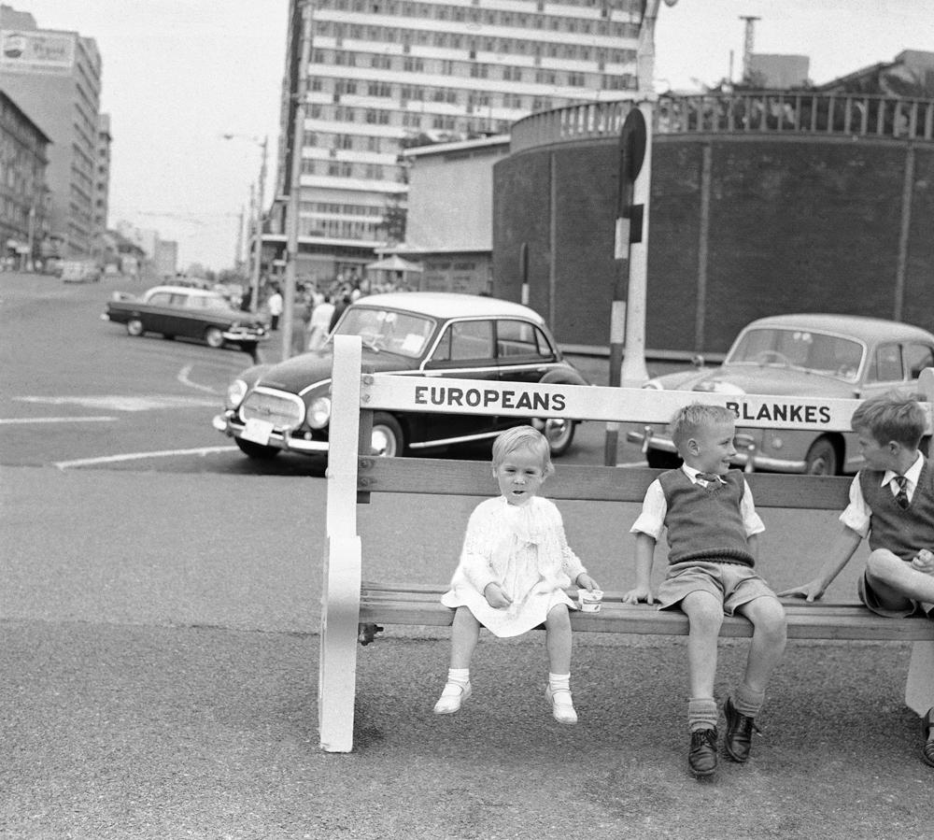
Apartheid

Liberation Movements in the Ukraine “Orange Crush” 2004

This liberation movement was in response to the Ukraine presidential election where the ‘declared’ winner Yanukovych was hand picked by the anti-democratic pro Russian president at the time. Yanukovych was accused of election fraud, voter intimidation, burning ballot boxes. The other candidate was poisoned and the public gathered to demand a re election in Kiev the nation's capital. They gathered for 17 days demanding a new election. The Supreme Court ruled the election invalid. A new election was held and Yushchenko was voted in as President. Yushchenko restored peace to the area and deepen the public's understanding of free and fair elections. Also, new emerging internet sites have become the watchdog of the people.

1. The best assessment of the Orange Revolution in 2004 would be:
a. The Ukrainian people were dissatisfied with the results of both the initial and subsequent election
b. The Ukrainians were satisfied with the second election results which they felt were free from election fraud
c. The Yanukovych government emerged victorious after the second election, to the delight of the people
d. All of the above

2. Which of the following best describes the situation in the Ukraine since the Orange Revolution?
a. the duly elected leader brought peace and harmony to the Ukraine
b. the Ukraine is headed back to a communist state c. there has been much turmoil with corruption and infighting
d. Yushchenko was assassinated by the pro-Communist movement
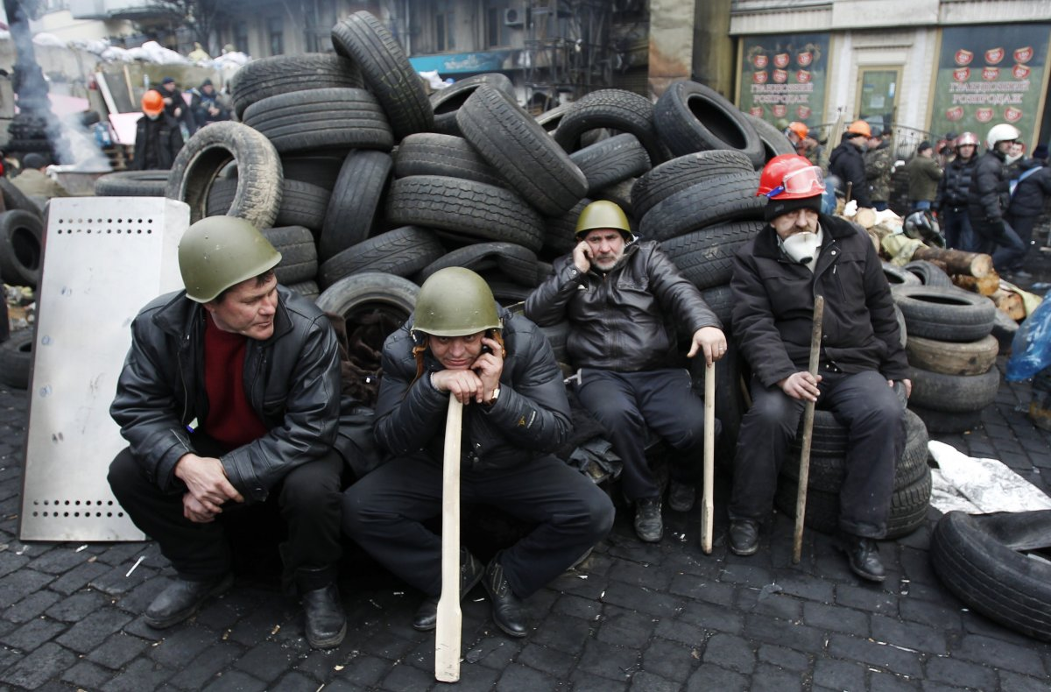

Vietnam War (Contain Communism; Domino Theory)
*Remember the Vietnam War the first send military advisers into Vietnam in 1950- 1973.

By 1960’s American Anti-War movement began slowly. Average age of service was 19 and average age of death was 22.8 month. By 1968 US government invoked the draft and a one year tour of duty was required. Those who did not wish to serve became draft dodgers in Canada and Sweden. Kennedy in 61 asks Canadian Prime Minister Pearson what to do. He is told to get out. Kennedy shot in 63. Lyndon B Johnson his vice president serves the remainder of the term and wanted domestic policy i.e civil rights for Blacks (Jim Crow Laws-Segregation). In January 1964, President Lyndon Johnson met with civil rights leaders. On January 8, during his first State of the Union address, Johnson asked Congress to "let this session of Congress be known as the session which did more for civil rights than the last hundred sessions combined." LBJ did not seek re-election because of his failed policy in Vietnam. President Nixon in. Vietnam is still a major problem. By late 1960’s the war is deemed not “Just” as media begins to leak pictures of the atrocities of the war. By 1968 over 3 millions American had served in Vietnam mostly low income and black american males. By April 1975 the Northern forces of Vietnam had taken over SAigon and in 1976 it is reinstated as a communist country. Internally for the United States the “Peace Marches” had a profound impact on the outcome of the vietnam War and American involvement.

6. Which of the following is most true of the Vietnam conflicts from the 50s to 70s?
a. Vietnam was unsuccessful against the French but won over the U.S.
b. Vietnam successfully repelled the French but not the Americans
c. Vietnam successfully defeated both the French and the Americans
d. None of the above

7. How did Lyndon B. Johnson deal with the unpopularity of the Vietnam War during his tenure as president?
a. He made detailed plans for the disengagement of troops from Vietnam
b. He announced he would not run again for office
c. He sent in even more troops to try to overcome the Vietcong
d. None of the above

8. Which group was most represented among the Vietnam draftees?
a. Middle class youth
b. Low-income Americans
c. African-Americans
d. a&b but not c
e. b&c but not a

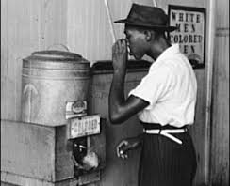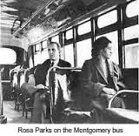
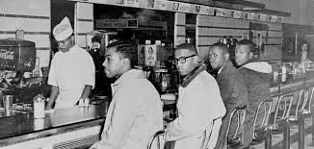

Jim Crowe Laws Full Citizenship Rights

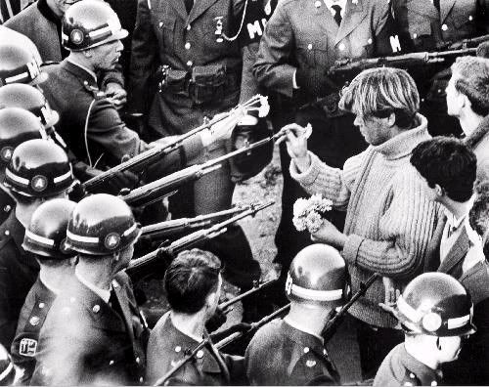

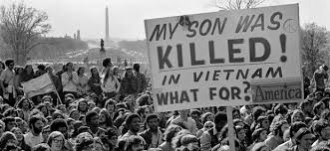

Vietnam War Liberation Movement Images

5 Ways to raise citizen awareness

- Take Part
- Question
- Include all
- Insist on accurate information
- Focus on the Local and the Living

Here are the instructions again: Simply number from 1-18, then place an "A" beside the number if you agree with the statement, or a "D" if you disagree. Add up the agrees you have listed for each even-numbered question. The higher the number of disagrees, the more open-minded you tend to be.
QUESTIONNAIRE
1. People should have a say in determining their fate, and the government should be led by people elected by a majority of the citizens.
2. Canadian and Japanese people have almost nothing in common.
3. The Canadian economic system ensures that poverty will be kept to a minimum.
4. Always compromising with our political opponents is dangerous because it usually leads to a betrayal of our own side.
5. A socialist economy is designed to benefit the group, rather than the individual.
6. Even though freedom of speech is a worthwhile goal, it is usually necessary to restrict the freedom of speech of some groups.
7. The average Canadian voter is generally well-informed about election issues.
8. A group that allows a great variety of opinion among its members will not exist very long.
9. One of the beliefs of the private enterprise system is that if all people were free to do exactly as they wanted, then the whole society would benefit.
10. In this complicated world, the only way we can ensure that the country is governed properly is to rely on leaders or experts who can be trusted.
11. The major problem with socialism is that it destroys people's incentive to work.
12. There are two kinds of people in this world; those who are truthful and those who are not.
13. There is little difference among socialists, Marxists and communists.
14. Among all the different philosophies in the world, there is probably only one that is correct.
15. A small economic elite has more influence on the Canadian government that the elected representatives (MP's).
16. Loyal political followers should read only their own party's newspaper.
17. It is impossible to have democracy in a socialist country.
18. I wish I could find someone to solve all my problems and tell me what to do.
19. Dictatorship is not much different from communism.

Course Review: Try. This will spearhead our course review.

14. Which of the following Enlightenment philosophers had the bleakest, or most negative, view of human nature?
a. Thomas Hobbes
b. John Locke
c. Montesquieu
d. Rousseau

15. The Canadian government supports diversity, immigration and inclusiveness, also referred to as:

a. progressivism
b. multilateralism
c. multiculturalism
d. bilingualism

16. Which of the following would individualist ideologies least support?

a. autonomy
b. classical liberalism
c. cooperation
d. innovation

17. NGO's are usually founded on which of the following?

a. individualism
b. collectivism
c. neither of the above
d. a combination of both

18. Which of the following do not belong together?

a. classical liberalism and capitalism
b. modern liberalism and socialism
c. welfare capitalism and classical liberalism
d. welfare capitalism and modern liberalism

19. Which of the following did not emerge out of the abuses of the Industrial Revolution?

a. Classical Liberalism
b. Chartism
c. Marxism
d. Utopian Socialism

20. The main difference between communism and fascism is:

a. fascism is extreme left wing and communism is extreme right wing
b. communism favors complete government control over the political system while fascism does not
c. fascism promotes internationalism while communism promotes ultranationalism
d. fascism is extreme right wing while communism is extreme left wing

21. The main difference between Marx's ideas about communism and Lenin's was:

a. Marx believed that communism could only take root in industrialized nations, while Lenin wanted to use communism to industrialize
b. Lenin believed that communism could take root only once Russia was industrialized, while Marx felt any country could successfully implement it
c. Marx felt that private property should be encouraged, while Lenin sought to have total government ownership of resources
d. None of the above

22. Which of the following is not a typical technique used by dictators to take or maintain control?

a. scapegoating
b. propaganda
c. freedom of speech
d. centralization of power

23. Which of the following is seen as a major flaw in classical liberalism that led to the emergence of modern liberalism?

a. there was a lessening in the gap between rich and poor
b. there was an increase in the gap between rich and poor
c. classical liberals were seen as too left wing
d. classical liberalism provided too many opportunities for the lower classes to better their situation

24. All of the following, but one occurred in the US in the 20s. Choose the exception.

a. Political conservatism
b. Xenophobia
c. increased isolationism as the government opposed the war
d. protests by those who opposed the war

25. Which of the following is not true of the Stock Market Crash, and subsequent Great Depression in the 30s?

a. Bank runs caused banks to go bankrupt
b. Many countries were not affected by the Depression
c. Make work projects were introduced
d. All of the above are true

26. What was the main economic shift in the 70s and 80s?

a. modern liberalism to monetarism (Friedman and money supply)
b. classical liberalism to modern liberalism
c. classical liberalism to monetarism
d. capitalism to socialism

27. Which of the following do not belong together?

a. monetarism - trickle down effect (Friedman. Control money supply)
b. capitalism - supply side economics
c. Keynesian - demand side economics
d. Keynesian - supply side economics

28. Which of the following was not directly linked to containment of communism?

a. Marshall Plan
b. NATO
c. Vietnam War
d. WWII

29. Which of the following communist nations was outside the immediate Russian sphere of influence?

a. Hungary
b. Yugoslavia
c. Czechoslovakia
d. East Germany

30. The onset of detente came about due to the brinkmanship and subsequent danger during the Cuban Missile Crisis.

True
False

31. The wars in Korea and Vietnam had virtually the same outcomes.

True
False

32. The USSR created the Warsaw Pact, presumably to protect itself from Western aggression, which led to the formation of NATO by the West.

True
False

33. Espionage was a key tool of the Cold War and helped both superpowers in their policies of expansionism and containment.

True
False

34. Labor laws and safety standards came about mainly due to the lower and middle classes becoming enfranchised.

True
False

35. Which of the following is most true of the Canadian Charter of Rights and Freedoms?

a. individual rights are addressed but collective rights are not
b. there are no limits on the types of freedoms individuals enjoy under the Charter
c. both individual and collective rights are addressed
d. the limits to rights found in the Charter are very specific

36. The major criticism of the War Measures Act is:

a. it may promote violence against protestors or other dissenters
b. it is an infringement, even if temporary, on individual liberty
c. it is usually racially motivated
d. all of the above

37. Which of the following is not seen as an example of government subtly restricting freedoms?

a. The Emergencies Act
b. Canada's No Fly List
c. War Measures Act
d. The USA Patriot Act

38. The sharing of what resource is a major source of contention among nations of the world today?

a. oil and natural gas
b. fresh water
c. renewable resources
d. iron and steel

39. What obligations) do citizens have to the nation as a result of being granted rights?

a. participation in defense
b. civic and political participation
c. participation in the economy
d. political and economic participation
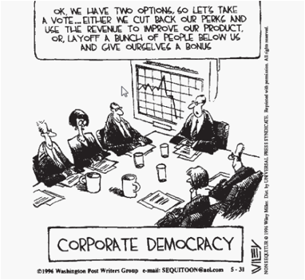
40. The cartoonist is critical of people who

a. place individual gain ahead of collective interest
b. sacrifice the well-being of a few to ensure the prosperity of many
c. believe that businesses should use a democratic process to make decisions
d. reduce corporate profits in order to improve the quality of consumer goods

STUDY NOTES
Chapter 7: Challenges to Liberalism Related to Foreign Policy
In 1945, the Big Three (Roosevelt, Stalin and Churchill) met to plan their remaining wartime actions and the future for postwar Europe. Germany had been divided into four zones, with Western nations controlling three, and Russian the fourth. The Western zones would be put back together, but Stalin refused to unite the fourth. The fourth became known as communist East Germany, and the other three became democratic West Germany. After the war, America and Russia emerged as the two main superpowers. The contest that would evolve for land, ideology, and weapons would become known as the Cold War.
During the Cold War, most of the world was split into two camps: those nation-states allied with the USSR and communism, and those allied with the US and democratic liberalism. Each country had what was called a Sphere of Influence. There were a few nations who chose non-alignment, or to not be formally aligned with either camp, such as Yugoslavia. Churchill's term, the iron curtain, described the line in Europe between democracies of the West and communist countries under Soviet control.
The Cold War was more of an ideological war than an actual physical conflict. The US and its allies sought the containment of communism, while the Soviets were expansionist, seeking to enlarge their communist empire. The Truman Doctrine was designed to contain Soviet expansion, not through hot war, but through alliances and aid. An example was the Marshall Plan which gave fund and technical expertise to countries ravaged by the war. The Soviets rejected Marshal Plan aid because of conditions that were contrary to their ideological beliefs.
In 1948, Stalin attempted to chase the West out of Berlin by imposing a blockade. The Allied forces responded by air lifting in supplies for about a year, forcing Stalin to concede and lift the blockade.In 1961, the East Germans installed the Berlin Wall to separate East Berlin, and East Germany from West Berlin and West Germany.
Several countries sought to break free of the Iron Curtain.
1. Hungary (1956)- a revolt by the Hungarians seeking to leave the Warsaw Pact and have free elections was squelched by the Soviets in a show of strength and warning to other satellite nations.
2. Czechoslovakia (1968)- During the Prague Spring, leader Dubcek granted rights and freedoms to citizens and loosened restrictions on the media, speech and travel. The Soviets eventually invaded and occupied Czechoslovakia, reversing Dubcek's reforms.
3. Yugoslavia (1955)- Leader Tito distanced his communist nation from the USSR, and became the first and only leader to defy Stalin and succeed in becoming non-aligned. Most feel this was because it did not have a mutual border with USSR.
Deterrence - the building up of one's capacity to fight such that neither opponent will fight because of the expected outcome.
Mutually Assured Destruction - deters each side from entering into direct conflict due to the assurance of total destruction
During the Cold War, collective security organizations such as NATO and NORAD were formed, to protect democratic nations from communist expansion. In response, the USSR created the Warsaw Pact in 1955 which all satellites were required to join.
Brinkmanship - the attempt to push a dangerous situation as far as possible (to the "brink") without creating a full-out conflict. The Cuban Missile Crisis was an example of the dangers of brinkmanship. Khrushchev of USSR and Kennedy of the US both realized that the stand-off could have resulted in mutually assured destruction, so Khrushchev pulled his missiles out of Cuba, Kennedy pulled his out of Turkey, and promised never to invade Cuba again. A hotline was installed between Moscow and Washington for future negotiations if necessary, and detente, a period of lessened tensions, ensued.
Over the later years of the Cold War, several treaties were signed to try to cope with the dangers and cost of the weapons race, such as SALT and START. (See Figure 7-15 on Page 256)
Examples of proxy wars (indirect fighting by either sphere) and liberation movements during this time were:
Korea and Vietnam - wars that had different results. Korea remained half communist and half democratic when the war ended, and Vietnam ended up fully communist.
Chile - CIA interference in elections saw Pinochet, a dictator sympathetic to the US, gain power until 1990.
Afghanistan - USSR invaded it in 1979, but Afghans were able to finally repel them after 10 years, with American backing.
Iran-Contra Affair - scandal erupted as it was made public that the US backed the Contras, a rebel group in Nicaragua.
Espionage - a key tool during this war that helped both superpowers keep an "eye" on each other. It is often credited for helping keep the Cold War a cold one.
Chapter 8: Contemporary Challenges to Liberalism
Utopia means an imaginary perfect world, while dystopia refers to a negative, pessimistic view of the world.
During the Industrial Revolution, Britain used the principles of classical liberalism, limiting government control over the economy. This led to a wide gap between rich and poor. This disparity helped alternative ideologies to develop, such as modern liberalism and environmentalism. Figure 8-3 on Pg. 274 show the evolution of liberalism.
Negative freedom, in the sense of classical liberalism, means "freedom from". Classical liberals supported laissez-faire government, and that there is a certain amount of inequality naturally.
The enfranchisement of the lower and middle classes helped lead to changes in how the government intervened in the economy, such as labor laws and safety standards because politicians wanted to get elected.
Modern liberalism supported positive freedoms, or "freedom to".
Environmentalism gained most of its popularity in the 1960s, and by the 70s Greenpeace and other organizations were pressuring governments to protect the environment through laws. Today different parties and governments make proposals for protecting the earth, such as carbon taxes, cap and trade system, and Kyoto Protocol.
Neo-conservatism means "new" conservatism and most challenge modern liberal principles in favor of a return to classical liberalism. Famous neo-conservatives include Margaret Thatcher of Britain, Reagan of the U.S., Ralph Klein of Alberta and many others.
Neo-conservatives, or supply-side supporters, argue that lower taxes in a free-market economy create conditions that give everyone a chance to prosper. They do not agree with the universal social services provided by most modern liberal governments. They favor individualism over collectivism.
As for foreign policy, they believe in patriotism, no world government, strong military and democratic capitalism.
Religious freedom and freedom of expression are favored by most liberal democracies, but limits must at times be placed when religious practice threatens the security or rights of others. The Christian Right, a huge right-wing conservative group, challenges modern liberalism.
Aboriginal collective thought also challenges liberalism, in that it supports the collective over the individual. Their style of justice can also challenge the principles of liberalism through the use of sentencing circles.

Chapter 9: Imposing Liberalism
Assimilation was a policy adopted by early British North American governments and liberal thinkers, to create an "ideal" situation where Aboriginals would give up their own ideologies and adopt liberalism. Even today, many Western liberal democracies have foreign policy goals of spreading liberalism to nations that have other ideologies in place.
Efforts to convince Aboriginals to embrace liberalism have included residential schools and enfranchisement, along with the Indian Act.
Trudeau's White Paper proposed to eliminate any prior agreements, treaties, etc. that had keep Aboriginals distinct from the rest of Canadians. However, his attempt to help them "catch up" to the rest of society was met with hostility, as these groups saw the paper as another attempt at assimilation. The result was a Red Paper drawn up by the Aboriginal groups in protest.
The Constitution Act of 1982 recognized and affirmed existing Aboriginal and treaty rights.
The two main reasons for the imposition of an ideology on other countries is:
-self-interest (eliminate terrorist threats, or economic reasons)
-humanitarianism (moral or ethical reasons)
Many see the War on Terror as an example of both types of reasons.
Some reasons why liberalism may fail in a country are: unemployment, inflation and civil unrest (i.e. Germany prior to rise of Hitler)
Many feel that the imposition of liberalism on a country can only be justified if the majority of its citizens are supportive of it.
Chapter 10: Political Challenges to Liberalism
Democracy is a form of government in which power is ultimately vested in the people. There are two main types: direct and representative.
Canada uses responsible government, parliamentary democracy, single-member constituency and representative democracy. Another key aspect is party solidarity, requiring that all party members vote with the party except in rare circumstances.
In referendums and plebiscites, all citizens may vote on whether to accept or reject a proposed piece of legislation. This is an aspect of direct democracy. These are rare in Canada: only three federal ones in history.
American also uses representative democracy and single-member constituency, but has a republican democracy rather than responsible government. Both have three branches of government: legislative, executive and judicial. American uses a system of checks and balances to keep one branch from becoming too powerful. Also, unlike Canada, citizens vote directly for the president, and for their local representatives.
Some countries, like Sweden, use proportional representation, where citizens vote directly for a party and representatives are assigned based on the amount of popular support obtained. These systems usually have more candidates represented, often from fringe or extreme parties, and are characterized by minority and coalition governments.
Some people feel that mandatory voting would be a good way to increase voter turnout, while others feel it goes against the very principles of democracy: freedom of choice.
Lobby groups use the democratic system to influence governmental policy or call attention to their interests.
When a group of individuals share ideas, solutions and concerns to find a resolution to a problem, it is called consensus decision making. Examples are the governments of Nunavut and NWT.
Authoritarianism refers to any type of government that gives authority to a elite group, that may or may not rule in the interests of the people. Examples are oligarchies, military dictatorships, one-party states, and monarchies.
Some techniques used by most authoritarian governments to gain and maintain power are:
- vision
-propaganda
-controlled participation
-directing public discontent
-fear and terror
Chapter 11: Complexities of Liberalism in Practice
Historically, some liberal democracies, such as Canada, have suspended the rights of citizens in order to protect the common good. The Canadian Charter of Rights and Freedoms entrenches fundamental rights such as individual and collective rights, subject to reasonable limits, such as promotion of hatred.
Some documents, such as the Quebec Charter of Human Rights and Freedoms focus almost exclusively on individual rights, rather than the rights of the community. Some constitutions are criticized as having little real power.
Collective rights are an extension on individual rights. An example of collective rights is affirmative action in the U.S.
Quebec's language legislation requires that all public signs and advertising must be in French. They can be in more than one language, providing French is dominant. Bill 101 makes French the common language of Quebecers in all spheres of public life.
Aboriginal land claims in Canada fall into two categories: comprehensive land claims and specific land claims.
Some liberal democracies, such as France, sometimes commit actions that seem illiberal, or against liberal policies, such as restricting the display of religious symbols in public.
Actions or laws, such as the War Measures Act, passed in 1914 in response to Canada's involvement in WWI, and the Anti-Terrorism Act enacted in 2001 after 911, are examples of liberal democracies temporarily violating liberal principles.
The War Measures Act involved Ukrainians in WWI, and Japanese Canadians in WWII, seen as enemy aliens because their countries of origin were at war with Canada and its allies. The third enactment of the War Measures Act took place during the FLQ Crisis in 1970.
The Emergencies Act deals with emergency situations and safeguards the rights of Canadians during these times.
Examples of government restricting freedoms in subtle ways include The USA Patriot Act of 2001 and Canada's No Fly List.
Chapter 12: The Viability of Contemporary Liberalism
Postmodernism has many definitions and manifestations, but can be defined as a movement that began as a reaction to modernism after WWI and WWII. It questions enlightenment values such as rationality, truth and progress, and liberalism in general. Modernism is, essentially, about order, universal truths, reason and rationality.
Extremism refers to a belief system that is outside the accepted norms of society, and can encourage actions that are considered socially or morally unacceptable. Examples might be Al Quaeda terrorism, Nazism, etc. Liberal democracies' response to extremism can include curtailing the civil liberties of citizens in order to preserve peace and safety. Economic extremism involves extreme activities that tend to go beyond the norm such as extreme capitalism or complete communism.
Consumerism is an outcome of classical liberal principles in that it glorifies the status and satisfaction of personal profit and the acquisition of material goods.
Some unanticipated outcomes of liberalism include: increased variety and quality of goods for some consumers, the ability of entrepreneurs to get rich sometimes at the expense of the masses, the reduction of food crops for cash crops in developing nations, the growth of unrest in the colonies, racism and even terrorism.
Activism has increased as an awareness of environmental change has occurred. Examples are Greenpeace and the Kyoto Protocol. Some governments, like Canada, are falling short of their Kyoto targets.
China and India are major examples of nations experiencing huge economic growth. Both have reduction in poverty and increases in the middle class. The down-sides are air pollution, over-crowding, the loss of agricultural land, etc. China concentrates mainly on low-cost manufacturing for export, while India prefers to provide services such as call centres and data-processing operations.
Pandemics, such as SARS, Bird Flu and most recently, Swine Flu, are outbreaks of a specific disease on a global scale. Organization such as WHO work to establish protocols and give out information regarding pandemics.
Water shortage is a major problem in much of the world today. Canada, among others, has an abundance of fresh water, but the issue today is whether these nations should have to share this valuable resource with other nations, even against their will? Some major causes of water shortage are: drought, dumping of pollutants into rivers, and the run-off of fertilizers from crops, etc.

Chapter 13: Reflecting on World view, Ideology and Citizenship
World view refers to a collection of beliefs about life and the universe held by an individual or group. and the overall perspective from which the world is interpreted. World view and ideology shape your evolving role as a citizen of your country and the world.
Legally, citizenship is based on two key principles: jus soli - determined by place of birth, and jus sanguinis - the citizenship and nationality of the child is the same as the natural parents, wherever the child was born.
A combination of these, plus naturalization (process of applying for citizenship) are used by most countries to decide who can call themselves a citizen of their country.
Some countries see dual, triple or multiple citizenship as a potential source of conflicting loyalties or legal confusions.
Citizenship can be seen in different ways: solely where you were born, where your parents were born, your heritage, and your past and/or where you live and work, your present loyalty, and where you see your future.
Civic and political participation are the obligations citizens have to the state and society as a result of being granted rights. Civic participation can be direct, indirect, or both. Civic advocacy refers to involvement in such things as writing letters to the editor, or contributing money to charities.
Human rights are not a new concept....they date back to 500 B.C. The Enlightenment helped to highlight the exploration of justice and human rights. Two major revolutions, the American and French, both included the idea of individual rights. The United Nations Universal Declaration of Human Rights was one of the more recent attempts to outline universal human rights.
Most documents highlight both negative human rights (i.e. liberties the government cannot infringe upon) and positive human rights (i.e. entitlements that the government is required to provide).
Figure 13-10 on Page 461 shows some rights and responsibilities of legal Canadian citizenship. Some Aboriginals do not regard Canadian citizenship in the same way as other Canadians.
For most Canadians voting is the most exercised right and responsibility, though voter turn-out is often disappointing. Other rights are fair trials, due process, etc.
Philanthropy is the concern and effort to improve the state of mankind. Many Canadians volunteer, donate, and provide expertise to help those in need. Crises such as earthquakes or tsunamis might expand the definition of citizen from "Canadian citizen" to "world or global citizen" as many people and organizations step up to help in these situations.
Those who are opposed to war, and are committed to peace are called pacifists. Many pacifists are religious, such as the Amish and Quakers, but most pacifists vary in how they interpret and act on their pacifism. A conscientious objector is one who is opposed to serving in the armed forces and/or bearing arms on the grounds of moral or religious principles. The UN supports the right to conscientious objection and monitors how they are treated.
Chapter 14: Reflecting on Ideology, Action, and Citizenship
The Orange Revolution in the Ukraine in 2004 involved a peaceful, massive protest against the results of an election that were blamed on election fraud. The people refused to back down until a new election was held, monitored by outside parties, and the peoples' choice was elected.
The Anti-apartheid movement in South Africa was led by a group of organizations described as liberation movements. Nelson Mandela led the ANC and used the law and civil disobedience to protect black Africans. Later, acts of violence occurred in retaliation for similar acts by the South African government.
Eventually, the world became involved in the South African fight, imposing sanctions and embargos on South Africa. South African was banned from the Olympics and banks refused it loans. Mandela was imprisoned for his actions, such as "plotting to overthrow the government with violence." He was freed from prison in 1990, and in 1994 the first interracial election was held in South Africa, with Mandela emerging as the first place president there.
The Vietnam War was essentially a civil war between the communist North and democratic South. The Americans became involved to aid South Vietnam, due mainly to a fear of the domino theory....that if one country fell to communism, they would all quickly fall. The war, however, quickly became unpopular in America, and an anti-war movement began. Young men were being drafted into the army and sent to Vietnam to fight.
Rather than fight, some young men joined the national Guard or Peace Corps, while others became draft-dodgers, fleeing to other countries such as Canada. Rallies and protests marches took place all over the U.S., and as it became clear that the war was "unwinnable" a peace treaty was signed by all parties in 1973. The fighting continued, however, until 1975 when Northern forces took Saigon and the entire country became communist.
Since the fall of the Taliban in Afghanistan in late 2001, Canada's military involvement has steadily increased, being involved in many offensive battles. Canada intended to be out by 2009, but Prime Minister Harper extended the mission until 2011. There is mixed reaction to Canada's involvement, with many people very opposed.
The minimal act of a citizen, according to a well-known philosopher, is voting. It gives us the power to alter society, and have a say in what goes on in our society.
Those who choose to challenge or question things in society can do so from outside or within. One must also consider his or her beliefs and values, the "act accordingly". An example of the world sitting by and not acting quickly enough is Rwanda, where attempted genocide of the Tutsis by the Hutus took place in 1994. An example of taking action quickly was the blockade in Cayoquot Sound by environmentalists.
"5 Ways to Raise Citizen Awareness" primarily focuses on making change on the local or provincial level, though it can sometimes have a global impact as well.

FINAL REVIEW
Go to the pages shown below to review important concepts. Read further on any that you don't remember or need clarification on. Be sure to re-read chapter summaries as well.
Pgs. 15-18 Enlightenment philosophers
Pg. 51 Themes of Ideology
Pgs. 71-75 & 78-79 Principles of Individualism
Pgs. 80-84 Principles of Collectivism
Pg. 104 Liberalism Development Timeline
Pgs. 146-147 & Pg. 219 Keynesian Economics
Pg. 168 Freedom-control Spectrum
Pg. 180 - communism
Pg. 186 Fascism
Pgs. 205-210 Depression/Welfare State
Pg. 228 Figure 6-16
Pg. 236 WWII timeline
Pg. 238 Cold War Map
Pg. 249 Alignment Map
Pg. 256-257 Cold War Events timeline
Pg. 274 Evolution of liberalism (Fig. 8-3)
Pg. 284 - Neo-Conservatism
Pg. 309-312 Indian Act
Pg. 339-343 Canadian vs American democracy, proportional representation
Pg. 361-364 Techniques of Dictatorships
Pg. 395 War Measures Act
Pg. 400 October Crisis
Pg. 447 Citizenship
Pg. 461 Rights & Responsibilities

