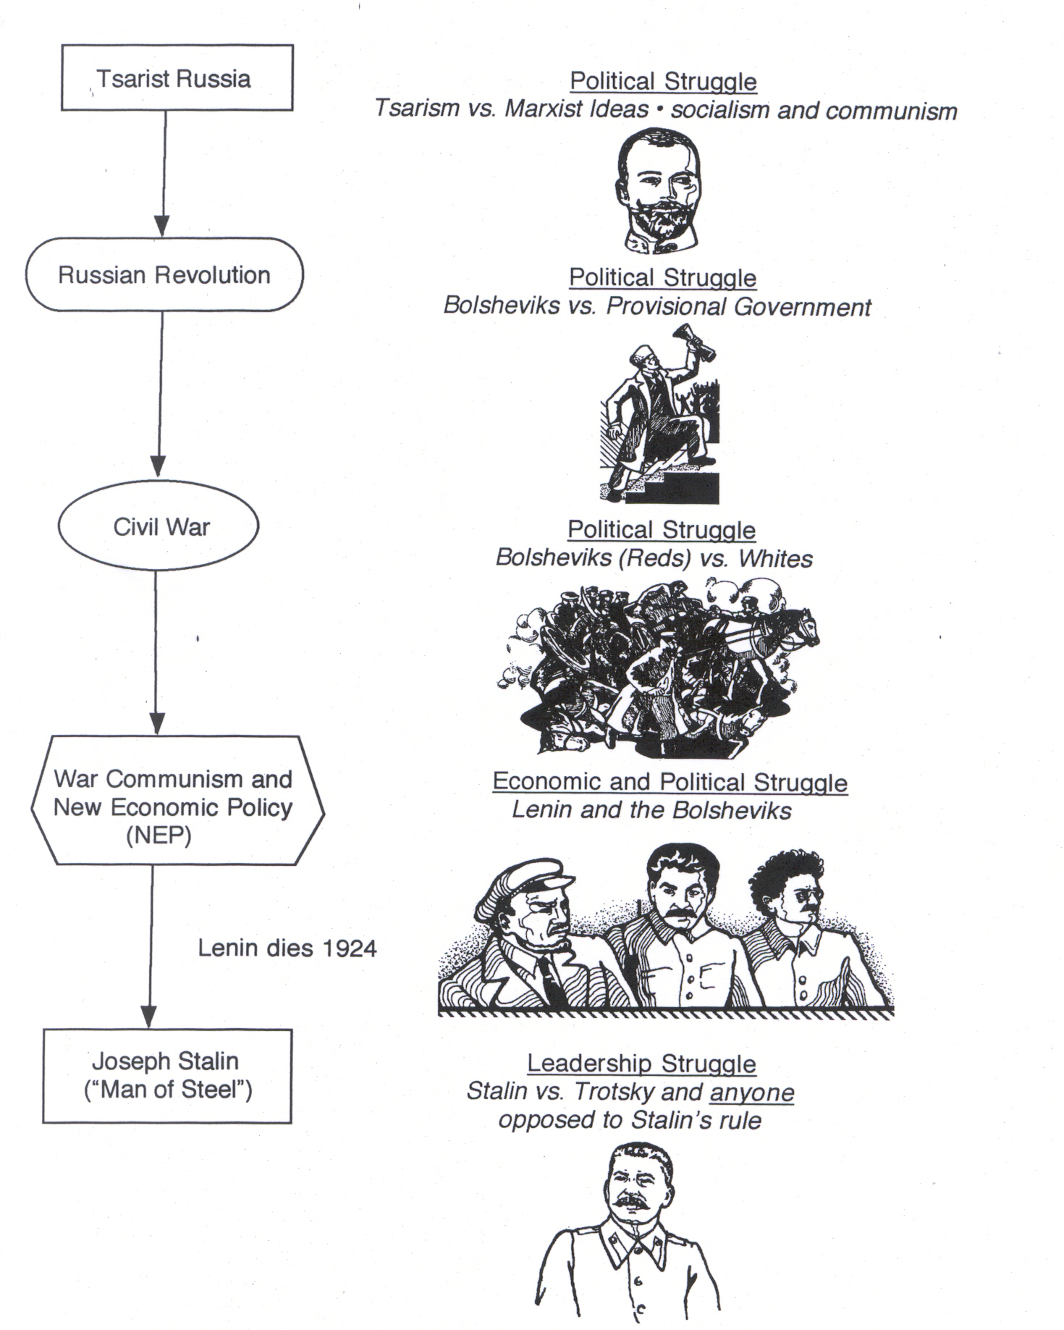
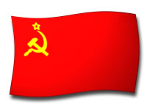
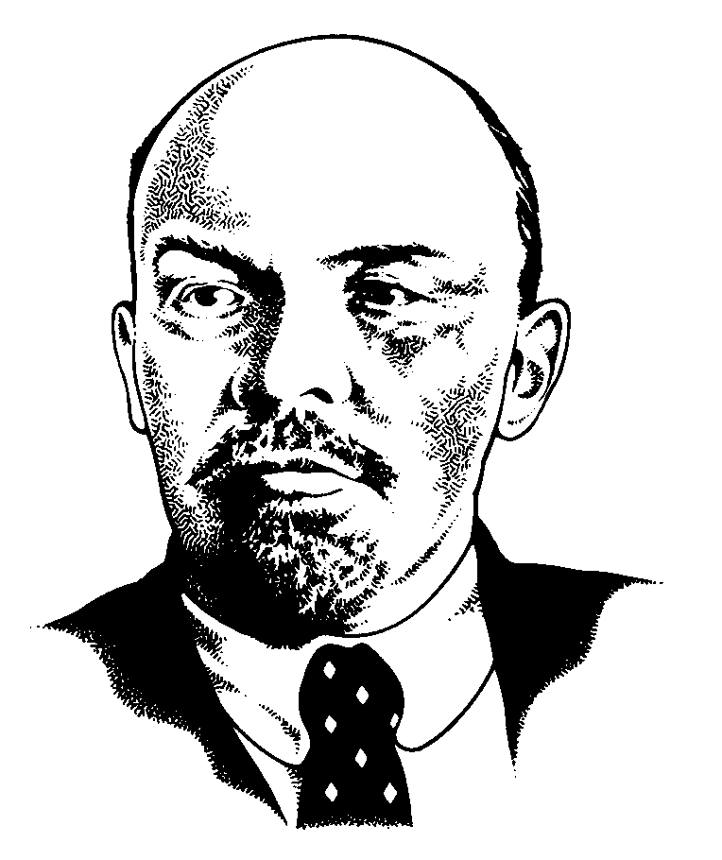
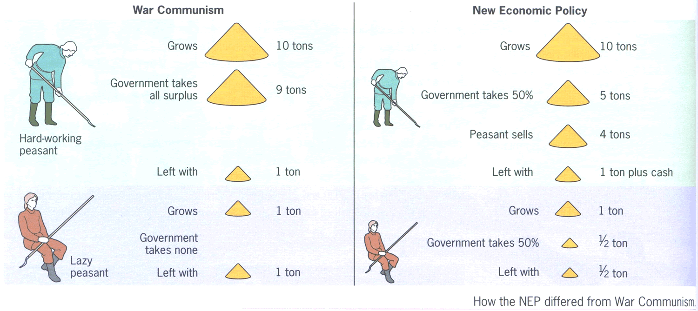
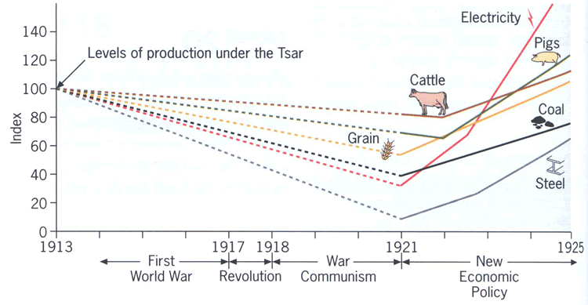

How the NEP differed from War Communism

Production under the New Economic Policy, 1921 - 25
What conclusions can you draw from the two visuals above?
Why would the NEP be criticized by supporters of communism?

