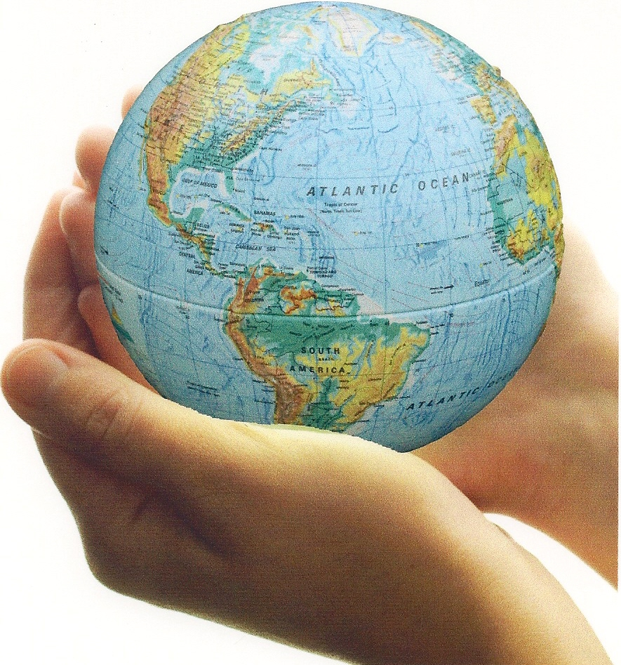

**The curricular outcomes for related issue 2 are listed below:**

2.1 appreciate Aboriginal contributions to the development of ideologies

1. 2.2 appreciate how citizens and citizenship are impacted by the promotion of ideological principles
2. 2.3 appreciate that individuals and groups may adhere to various ideologies
3. 2.4 explore Aboriginal contributions to the development of liberalism

2.5 examine the relationship between the principles of liberalism and the origins of classical liberal thought (John Locke, Montesquieu, Adam Smith, John Stuart Mill)

2.6 analyze the impacts of classical liberal thought on 19th century society (laissez-faire capitalism, industrialization, class system, limited government)

2.7 analyze ideologies that developed in response to classical liberalism (classic conservatism,

Marxism, socialism, welfare capitalism)

2.8 analyze the evolution of modern liberalism as a response to classical liberalism (labour standards and unions, universal suffrage, welfare state, protection of human rights, feminism)

2.9 evaluate ideological systems that rejected principles of liberalism (Communism in the Soviet

Union, fascism in Nazi Germany)

2.10 analyze how ideological conflict shaped international relations after the Second World War

(expansionism, containment, deterrence, brinkmanship, détente, nonalignment, liberation movements)

2.11 analyze perspectives on the imposition of the principles of liberalism (Aboriginal experiences, contemporary events)

2.12 analyze the extent to which modern liberalism is challenged by alternative thought (Aboriginal collective thought, environmentalism, religious perspectives, neo-conservatism, postmodernism, extremism)

2.13 evaluate the extent to which resistance to the principles of liberalism is justified

**In the textbook we explored the following:**

classical liberalism

American Revolution

French Revolution

Montesquieu

capitalism

rule of law

Age of Reason

John

Locke

traditional economy

Enlightenment

laissez-faire

industrialization

free market

Adam Smith

class system

**Chapter 3 Issue**:

To what extent can classical liberalism

impact a society?

John Stuart Mill

rights and freedoms

civil

liberties

limited government

welfare capitalism

Great Depression

Utopians

Edmund Burke

classical conservatism

communism

**Chapter 4 Issue**:

To what extent did classical liberalism

meet the needs of society?

progressivism

Chartists

command economy

universal suffrage

John Maynard Keynes

socialism

labour unions

Marxism

labour standards

human rights

CCF

feminism

Luddites

Mary Wollstonecraft

**Chapter 5 Issue**:

To what extent is the rejection of liberalism justified?

propaganda

proletariat

hyperinflation

Treaty of Versailles

Adolf Hitler

Great Purge

Lenin

communism

collectivization

Hitler

Youth

Nazism

Czar (Tsar)

scapegoat

Stalin

dissent

totalitarianism

reactionary

censorship

radical

fascism

authoritarianism

**Chapter 6 Issue**:

To what extent do contemporary economic policies and practices reflect the principles of liberalism?

Keynesian economics

Roaring twenties

‘Red Scare’

Friedman and Hayek

progressivism

Great depression

inflation

demand-side economics

New Deal

stock market crash

monetarism

FDR

Welfare state

trickle-down economics

social programs

income disparity

monopoly

consumerism

monetary and fiscal policy

Reaganomics and Thatcherism

supply-side economics

**Chapter 7 Issue**:

To what extent does

ideological conflict

shape our world?

espionage

Proxy Wars

iron curtain

MAD

Korean

War

containment

McCarthyism

Cuban Missile Crisis

Vietnam

War

superpower

Berlin Wall

Nonalignment

expansionism

deterrence

Cold War

detente

brinkmanship

sphere of influence

Marshall Plan

liberal movements

Christian right

enfranchisement

**Chapter 8 Issue**:

To what extent is

modern liberalism

continuing to evolve?

positive freedom

environmentalism

foreign policy

Neo-conservatism

civil rights movement

civil rights

Aboriginal justice

consensus

fundamentalism

negative

freedom

**You should have a working understanding of the political and economic spectrum below:**

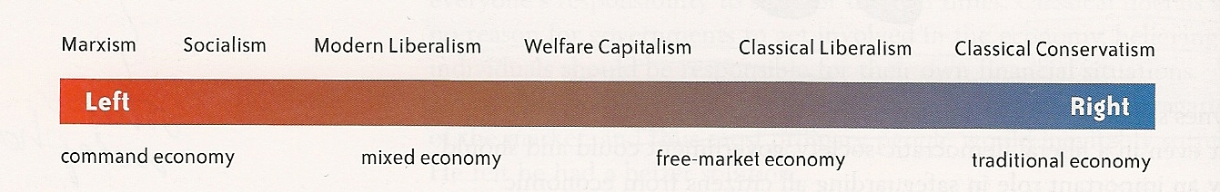

**Essential understandings:**

* you need to understand the principles of liberalism
* you need to understand the ideological contributions of John Locke, Montesquieu, Adam Smith, John Stuart Mill
* you need to understand the differences between classical liberalism and modern liberalism
* you need to understand the impacts of classical liberal thought on 19th century society (laissez-faire capitalism, industrialization, class system, limited government)
* you need to understand the evolution of modern liberalism as a response to classical liberalism (labour standards and unions, universal suffrage, welfare state, protection of human rights, feminism)
* you need to understand ideologies that developed in response to classical liberalism (classic conservatism, Marxism, socialism, welfare capitalism
* you need to understand the degrees of socialism (socialism, communism, Stalinism)
* You will need to know the following about Nazism and Stalinism:
* *the pre-conditions that allowed the regimes to come to power*
* *the rise to power, including how power was taken*
* *the placement of each system on the political and economic spectrum*
* *the illiberal practices of the regime while in power (techniques of dictatorship)*
* you need to understand the similarities and differences between fascism and communism
* you need to understand how Stalinism and Nazism used various techniques to undermine the principles of liberalism
* you need to understand how ideological conflict shaped international relations after the Second World War (expansionism, containment, deterrence, brinkmanship, détente, nonalignment, liberation movements)
* you need to understand how modern liberalism is challenged by alternative thought (Aboriginal collective thought, environmentalism, religious perspectives, neo-conservatism, postmodernism, extremism)
* you need to be able to explore aboriginal perspectives and contributions to the development of liberalism