The curricular outcomes for related issue 3 and 4 are listed below:

3.1 appreciate various perspectives regarding the viability of the principles of liberalism
3.2 appreciate various perspectives regarding the promotion of liberalism within political and economic systems
3.3 explore the extent to which governments should reflect the will of the people
3.4 explore the extent to which governments should encourage economic equality
3.5 analyze the extent to which the practices of political and economic systems reflect principles of liberalism (consensus decision making, direct and representative democracies, authoritarian political systems, traditional economies, free market economies, command economies, mixed economies)
3.6 analyze the extent to which liberal democracies reflect illiberal thought and practice (Canada, contemporary ex.)
3.7 analyze why the practices of governments may not reflect principles of liberalism
3.8 evaluate the extent to which governments should promote individual and collective rights (American Bill of Rights; Canadian Charter of Rights and Freedoms; Québec Charter of Human Rights and Freedoms; First Nations, Métis and Inuit rights; language legislation; emergencies and security legislation)
3.9 evaluate the extent to which the principles of liberalism are viable in the context of contemporary issues (environment concerns, resource use and development, debt and poverty, racism, pandemics, terrorism, censorship, illiberalism)
4.1 appreciate the relationship between citizenship and leadership
4.2 exhibit a global consciousness with respect to the human condition and world issues
4.3 accept responsibilities associated with individual and collective citizenship
4.4 explore the relationship between personal and collective worldviews and ideology
4.5 explore how ideologies shape individual and collective citizenship
4.6 analyze perspectives on the rights, roles and responsibilities of the individual in a democratic society (respect for law and order, dissent, civility, political participation, citizen advocacy)
4.7 analyze perspectives on the rights, roles and responsibilities of the individual during times of conflict (humanitarian crises, civil rights movements, antiwar movements, McCarthyism, prodemocracy movements, contemporary examples)
4.8 evaluate the extent to which ideology should shape responses to contemporary issues
4.9 develop strategies to address local, national and global issues that demonstrate individual and collective leadership
4.10 explore opportunities to demonstrate active and responsible citizenship through individual and collective action

In the textbook we explored the following:
White Paper
Red Paper
Nisga’a
Agreement
NATO
Haudenosaunee Confederacy
Question for Inquiry #2:

To what extent has the imposition of liberalism affected people globally?
Question for Inquiry #1:

To what extent has the imposition of liberalism affected Aboriginal groups in Canada?
Chapter 9 Issue:

To what extent, and for whom, has the imposition of
liberalism been
successful?

land holding
war on
terror
Royal Commission
assimilation
Indian Act
enfranchisement

Canada in Afghanistan

elite
directing popular discontent
propaganda
controlled participation
lobby (interest) groups
Senate
House of Commons
oligarchy
authoritarianism
party solidarity
secret
police
Question for Inquiry #2:

How, and to what extent, are government actions that ignore the will
of the people justified?
Question for Inquiry #1:

How do governments attempt to follow
the will of the people?
Chapter 10 Issue:

To what extent should governments reflect the
will of the people?

one-party state
constituency
(riding)
military
dictatorship
republic
direct
democracy
proportional representation
representative democracy

responsible government

consensus

pandemic
extremism
October Crisis
U.S.
PATRIOT Act
War Measures Act
collective rights
individual rights
liberal democracy
Quebec Charter of Rights and Freedoms
language legislation
illiberal
Question for Inquiry:

How do some contemporary issues raise questions about the viability of liberalism?
Question for Inquiry:

What solutions to contemporary issues are supported by the principles of liberalism?
Kyoto Protocol
postmodernism
American Bill of Rights
environmental activism
Anti-terrorism Act
Question for Inquiry:

Why might liberal democratic governments choose to reject the principles of liberalism in some cases?
Question for Inquiry:

Why and to what extent do some liberal democratic governments promote individual and/or collective rights?
Chapter 11 and 12 Issues:

To what extent should governments promote and protect individual and collective rights? To what extent do contemporary issues challenge the principles of liberalism?

emergency
and security legislation
Canadian Charter of Rights and Freedoms
Question for Inquiry:

How do liberal democracies balance the perceived common good with the need to respect rights?

civil rights movement
dissent
non-violence
worldview
draft
dodger
civil liberties
‘just war’
conscientious objector
pacifism
citizenship
advocacy
civility
draft
pro-democracy movement
philanthropy
status
Indian
Charter of Rights and Freedoms
naturalization
political participation
anti-war movement
Question for Inquiry:

To what extent do citizens have a right, role, or responsibility to take action?
Question for Inquiry:

How do your ideology and your citizenship affect how you demonstrate leadership in responding to local, national, and global issues?
election fraud
liberation movements
positive human right
apartheid
negative human right
Question for Inquiry:

In what ways do people demonstrate their rights, roles and responsibilities as citizens?
Question for Inquiry:

How do personal and collective worldviews and ideology influence citizenship?
Chapter Issues:

To what extent should ideology shape responses to issues in times of peace and times of conflict? To what extent should an ideology shape your thinking and actions as a citizen?

individual rights, roles and responsibilities
citizenship

You should have a working understanding of the political and economic spectrum below:

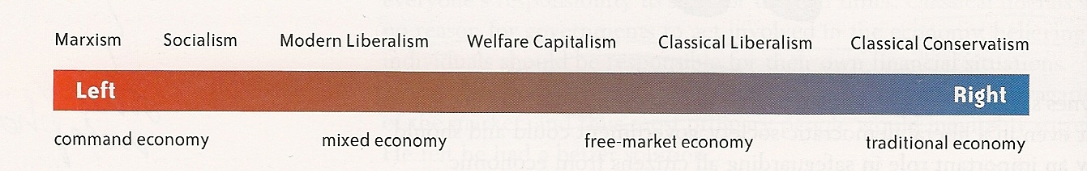

Essential understandings:

- you need to have a general understanding about how many aboriginal peoples have values that are often in conflict with the principles of liberalism (individualism). For example: the European concept of private property was a foreign concept to many aboriginal people - an issue when it came time to make treaties.

- you need to understand the terms below in the context of Canada:
-First Nations treaties, land claims, self-government

- you should know some historical case studies where the imposition of the principles of liberalism have been controversial (some successful and some unsuccessful). Possible case studies/examples (see Moodle responses):

  - democracy, freedom and capitalism in Iraq
  - democracy, freedom and capitalism in post-WWII Japan
  - democracy, freedom and capitalism in Afghanistan
  - residential schools in Canada
  - self-government in Nunavut
  - democracy, freedom and post-World War II Japan
  - capitalism in China
  - democracy, freedom and capitalism in the Former U.S.S.R. and Eastern Bloc countries

  - you should review the basic principles of liberalism (individualism) and collectivism
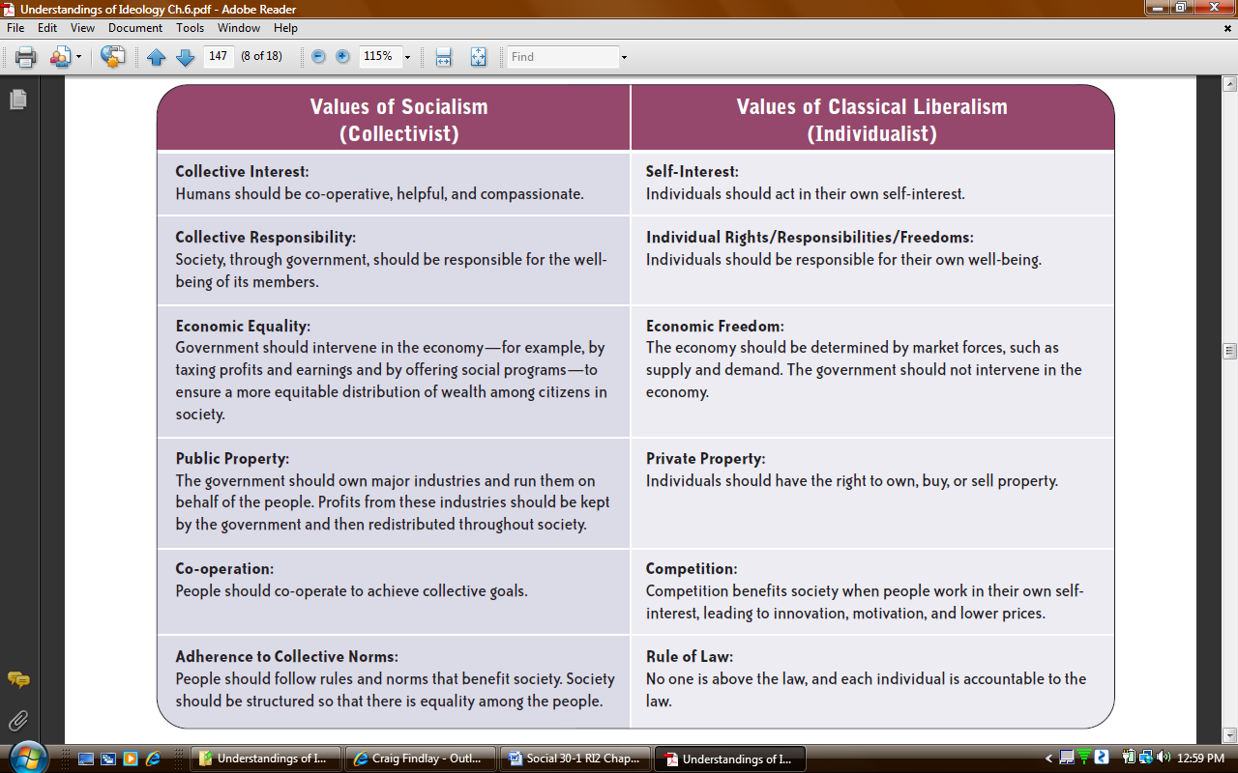

EFFECTS

- you need to understand how practices of political and economic systems reflect principles of liberalism (consensus decision making, direct and representative democracies, authoritarian political systems, traditional economies, free market economies, command economies, mixed economies)

- you need to understand basic liberal democratic principles (majority rule, secret ballot, frequent elections, protection of minority rights, guaranteed rights and freedoms, media ‘watchdog’, interest/lobby groups, universal suffrage, political accountability, representation by population, separation of powers)

- you need to understand the major differences between the Canadian and American political systems (see mind maps from chapter 10)
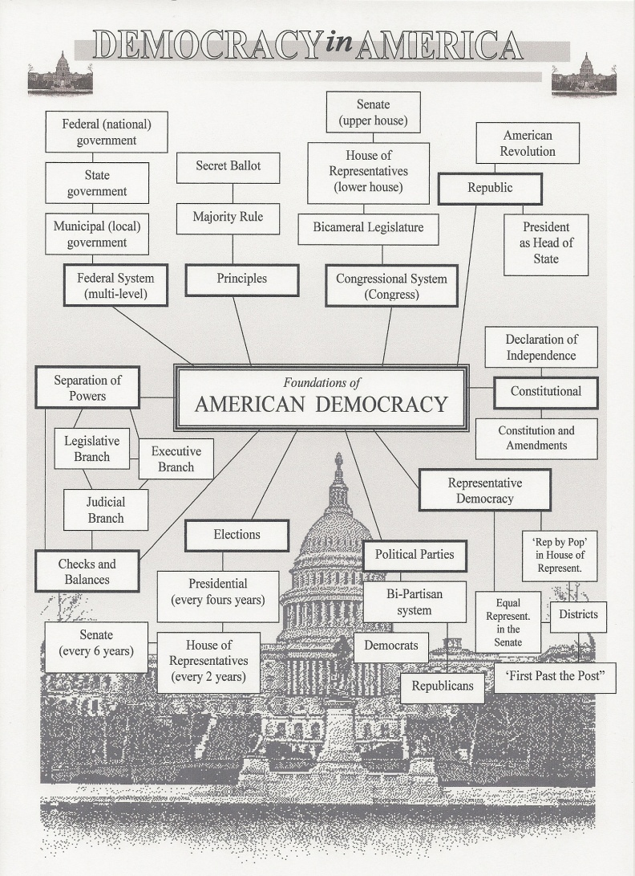
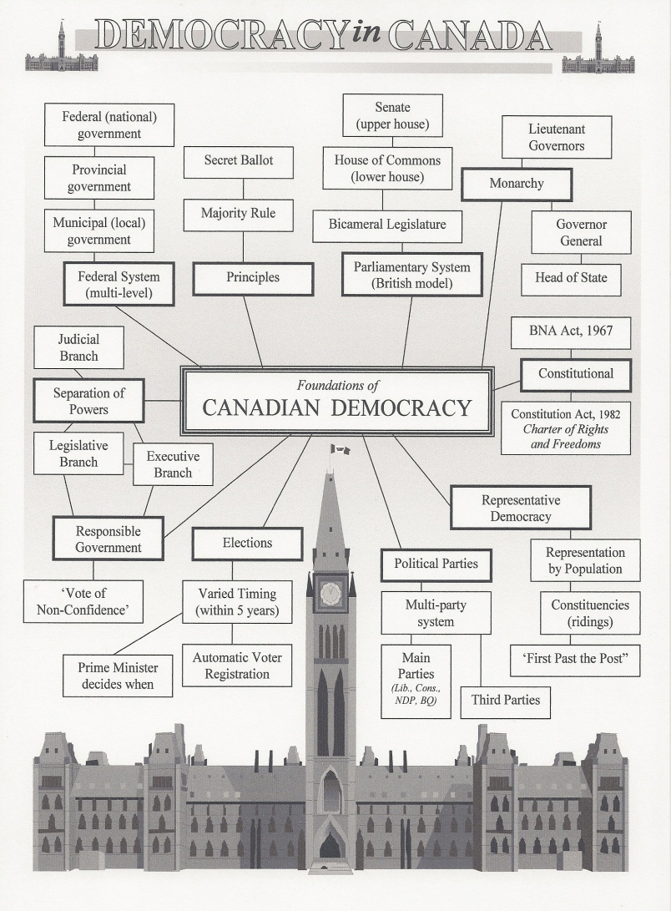

- you need to be able to critique liberal democracies and their ability to reflect the will of their citizens – Canada’s parliamentary system and the American republican system. Potential areas of critique;
- party solidarity and party discipline
- ‘crossing the floor’
- ‘first-past-the-post’ (FPTP) electoral system
- representation by population
- election timing
- checks and balances versus responsible government
- role of the Governor General and the monarchy

- you need to understand how various governments promote individual and collective rights and know the bracketed items do that within their given context (American Bill of Rights; Canadian Charter of Rights and Freedoms; Québec Charter of Human Rights and Freedoms; First Nations, Métis and Inuit rights [Indian Act, land claims, treaties, self-government]; language legislation [Official Languages Act, Bill 101, Bill 178]; emergencies and security legislation [War Measures Act, Canadian Emergencies Act, U.S. Patriot Act])

- you need to understand the basics of the issues surrounding the viability of liberal principles in the context of various contemporary issues (i.e. environment concerns, resource use and development, debt and poverty, racism, pandemics, terrorism, censorship)

- you need to understand the rights, roles and responsibilities of the individual in a democratic society (respect for law and order, dissent, civility, political participation, citizen advocacy)

- you need to understand the complexity of rights, roles and responsibilities of the individual during times of conflict (humanitarian crises, civil rights movements [U.S. Martin Luther King], antiwar movements [Canada and U.S. – conscientious objectors, ‘draft dodgers’], McCarthyism [‘Red scare’], prodemocracy movements, [prodemocracy movements in India, Iran, China, South Africa;

- you need to understand strategies to address local, national and global issues that demonstrate individual and collective leadership, and active and responsible citizenship through individual and collective action

