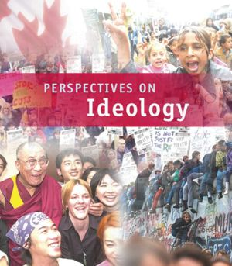
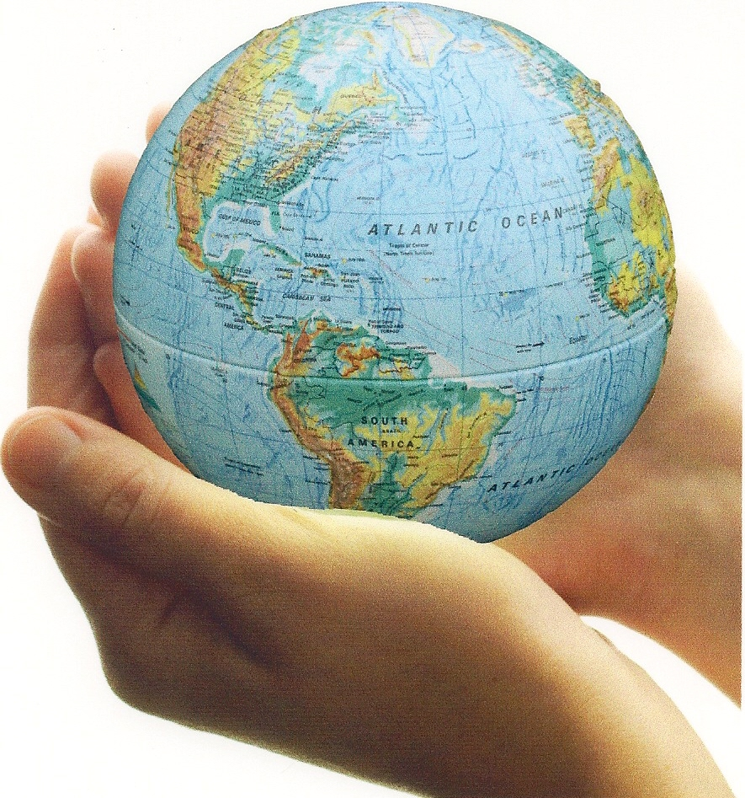

RELATED ISSUE 2: CHAPTER 3
WHERE ARE WE GOING

By the end of this chapter you will have to respond to the questions for inquiry listed below and demonstrate a contextual understanding of the vocabulary, concepts, people and events listed.

Chapter Issue:

To what extent can classical liberalism
impact a society?
Question for Inquiry #1:

What factors were most important in bringing about the emergence of classical liberalism?
Question for Inquiry #2:

How did classical liberal thought evolved into the principles of liberalism?
Question for Inquiry #3:

How did classical liberalism influence 19th- century society?

American Revolution
rule of law

traditional economy

Adam Smith
John Stuart Mill
Enlightenment

John
Locke

French Revolution
Montesquieu

class system
rights and freedoms

civil
liberties
free market

industrialization
laissez-faire
Age of Reason
classical liberalism
capitalism

limited government

\

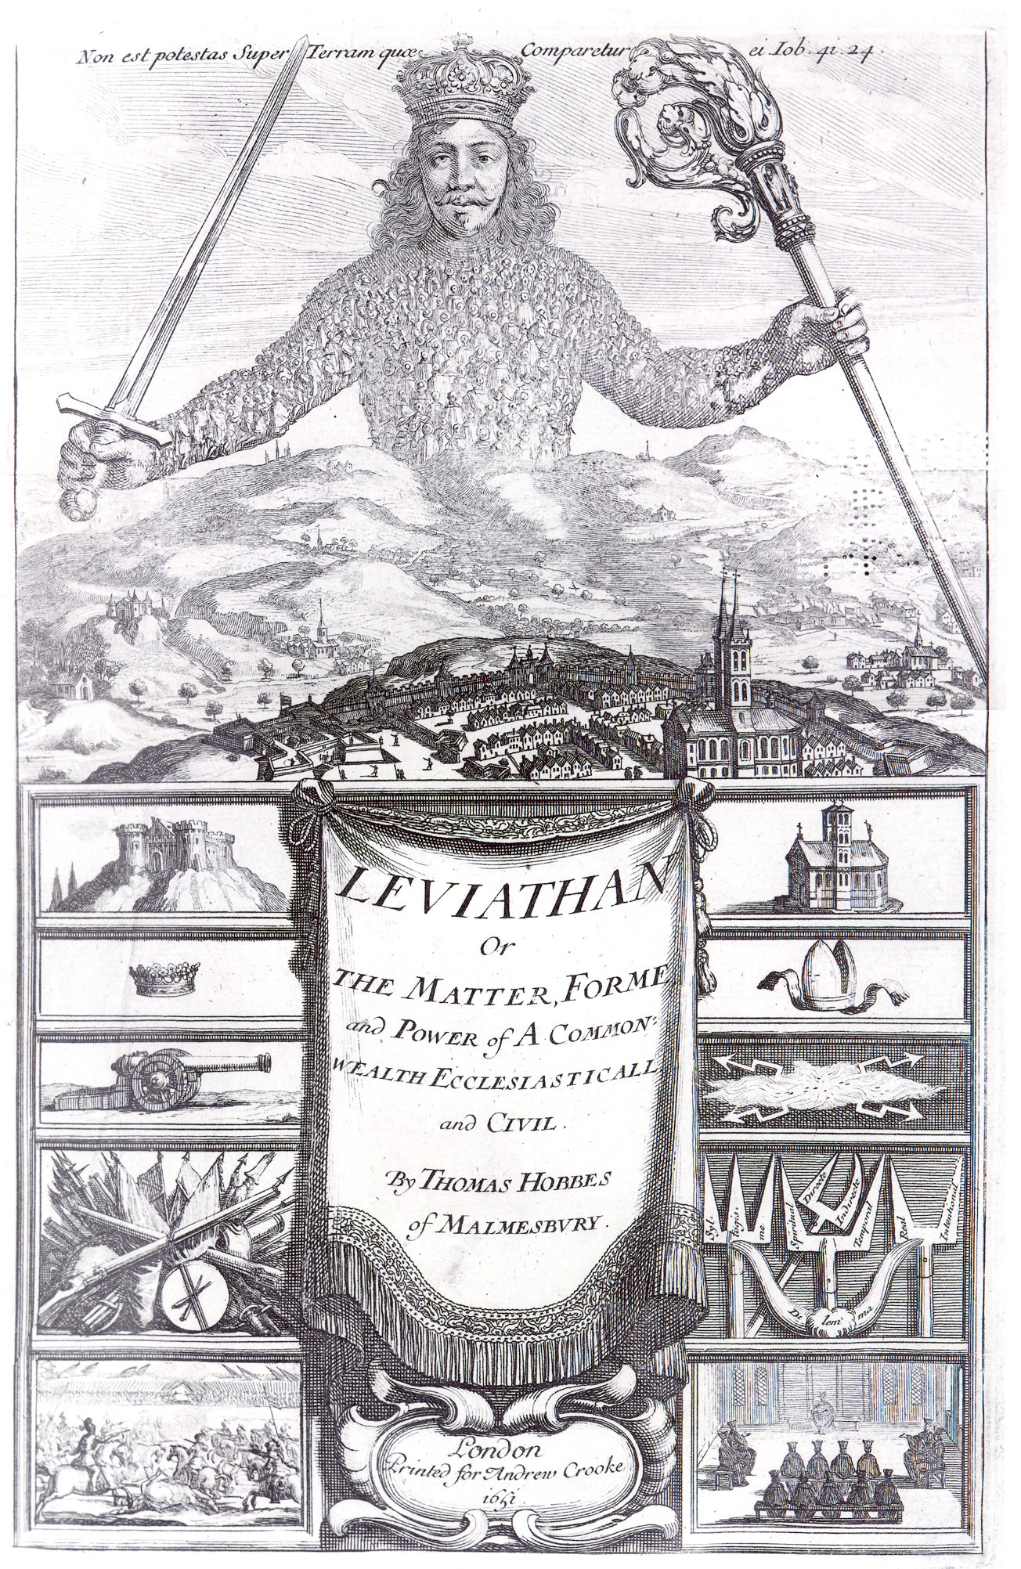

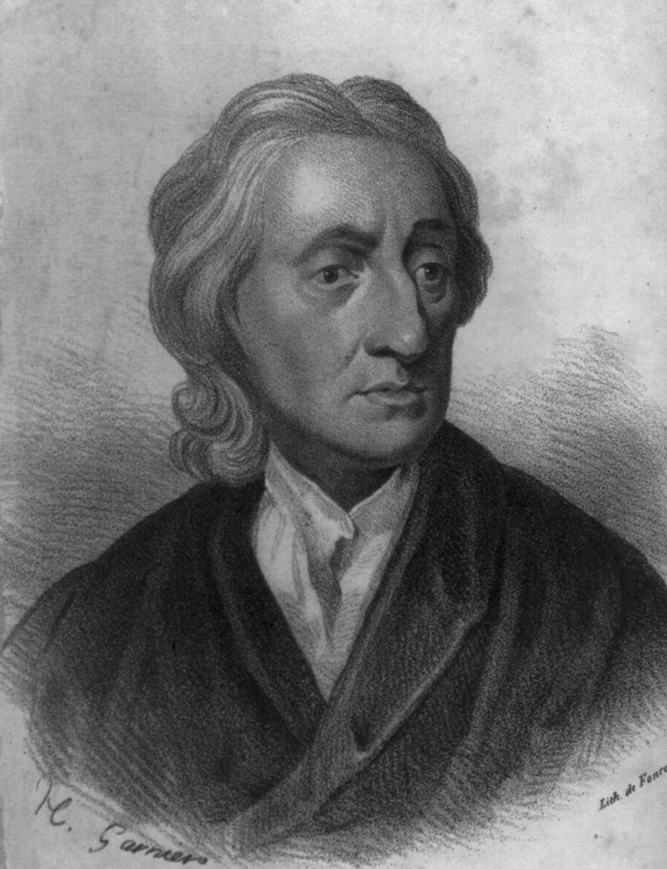

Two Treatises of Government

I hope my book demolishes the main authoritarian/totalitarian ideology of the day. The doctrine of the divine right of kings,
and absolute arbitrary power over human subjects, is for a time long past and must change. However, there must be limits on government. Far from God and natural law ordaining all-powerful hereditary dictatorship, the only legitimate form of government is one established by the consent of the people and committed to upholding their fundamental human rights to life, liberty, and property.

I hope my book has helped to justify the Glorious Revolution that has established parliamentary government in my homeland. A limited monarchy has been born in England and I hope my words and will inspire other revolutions throughout the world. I hope I can help to support the notion that human nature is not necessarily evil, promoting the realization that human beings can indeed govern themselves. If more governments move to support the rights of individuals and allow them to protect that which is theirs, then my work will have been worthwhile.

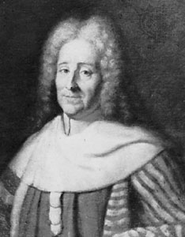

The Spirit of the Laws

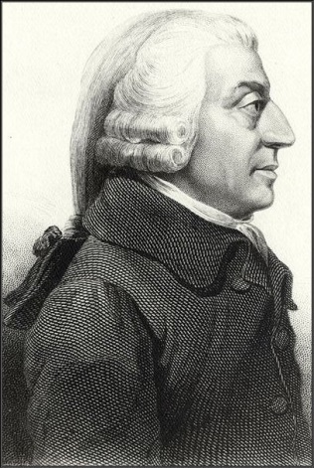

The Wealth of Nations

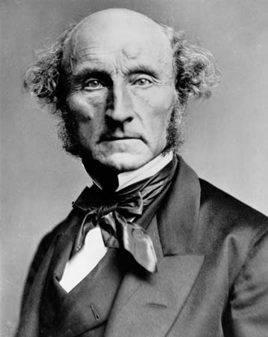

On Liberty

Use the following information from another Oxford textbook (Understandings of Ideology) to answer the question that follows:
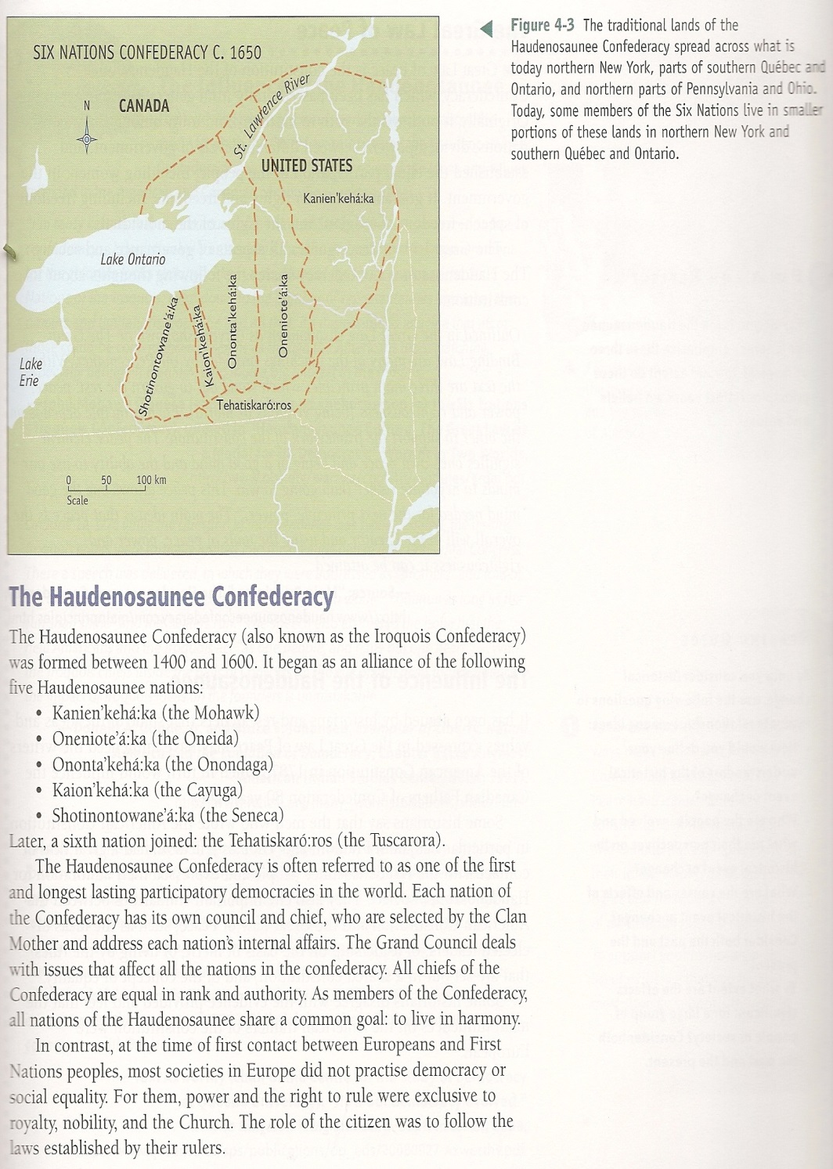

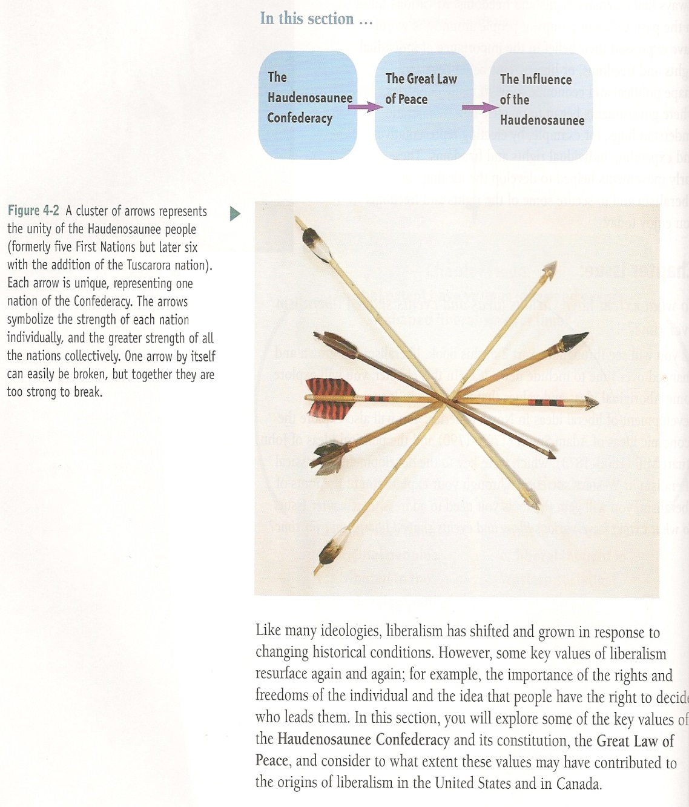

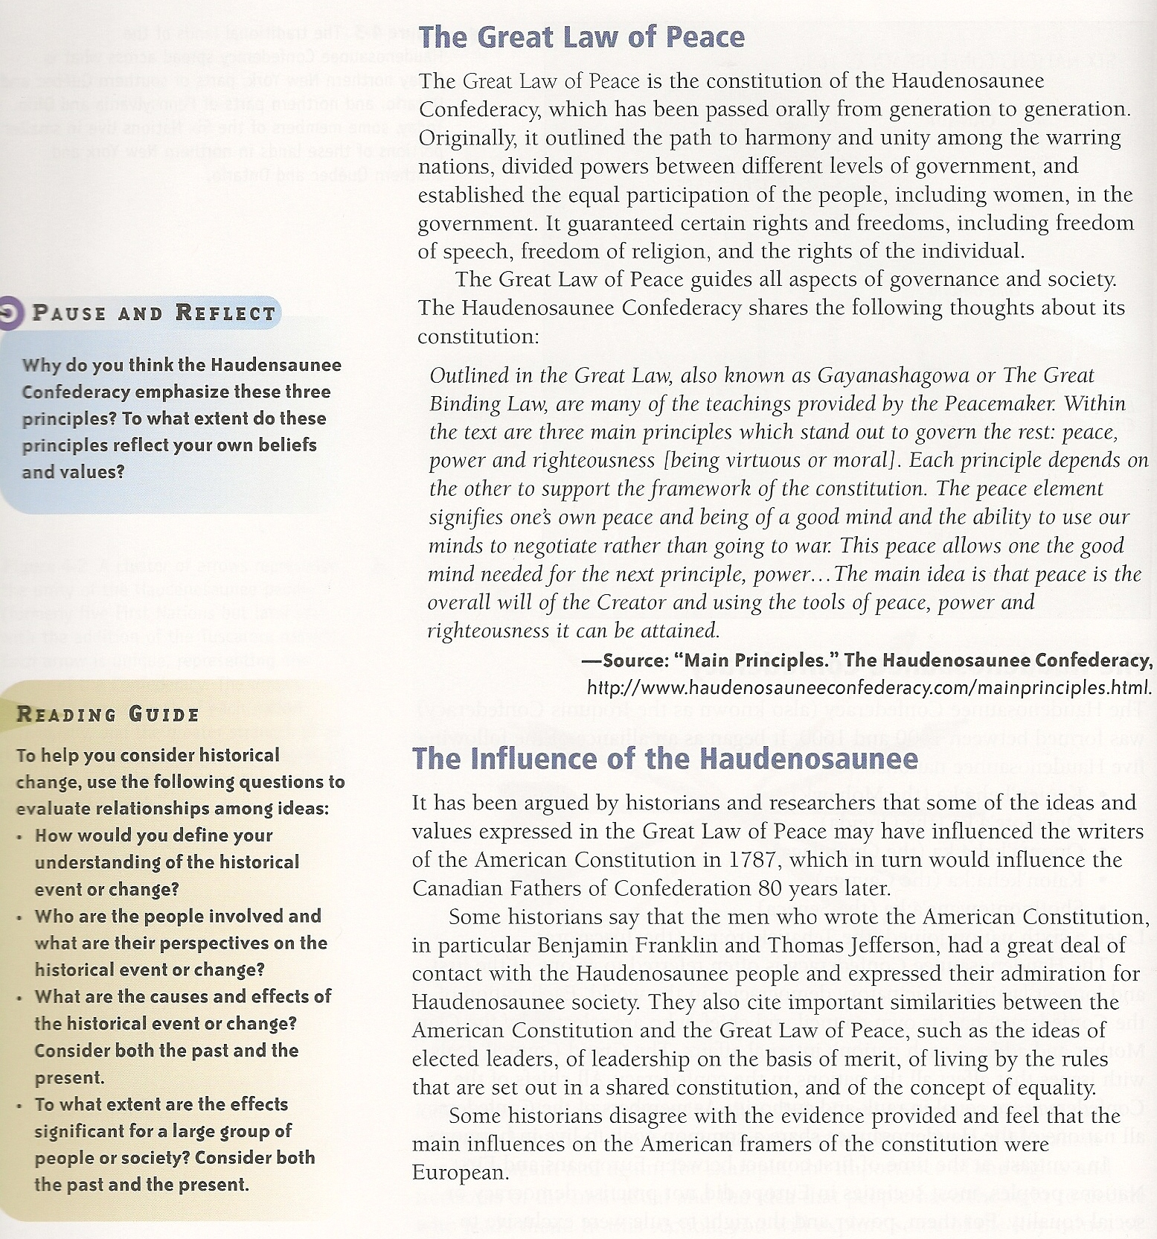
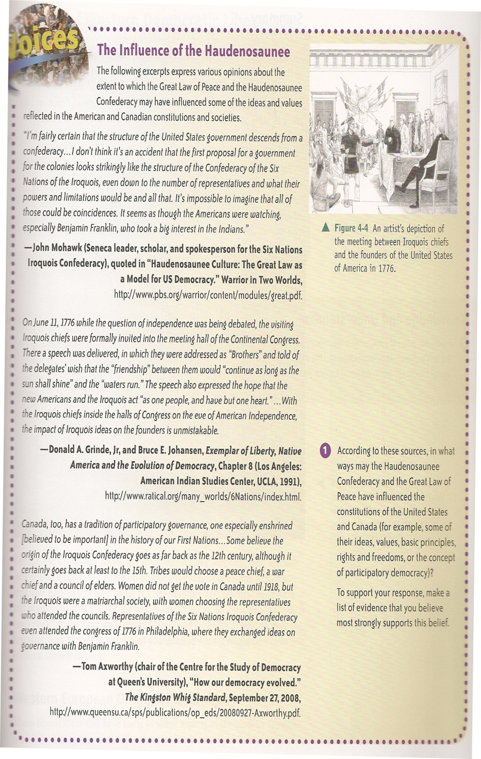

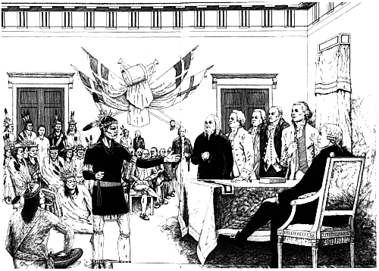
Excerpt from Exemplar of Liberty: Native America and the Evolution of Democracy
By Donald A. Grinde, Jr. Rupert Costo Professor of American Indian History University of California at Riverside and Bruce E. Johansen Associate Professor of Communication University of Nebraska at Omaha. Original Artwork by John Kahionhes Fadden

The founders of the United States knew more about how American Indians governed themselves than we do. The perceptions of the founders were selective, and subject to embellishment, but they had the advantage of observing native societies in their full flower. We have only their written recollections, along with surviving shreds of the native peoples' own oral histories, analysis by contemporary scholars, novelists, and movie makers who, like all of us, look at the past through filters of time and predisposition.
We do know that America's indigenous cultures had been forming, evolving, and dissolving for many thousands of years before permanent European settlements began in North America. But we do not know for how long. Modern archaeology keeps pushing back the date it finds acceptable for the beginnings of native occupancy in the Americas. A few years ago, a five-figure date was considered risky. Speculation now flirts with a quarter million years, reminding us once again that pre-history holds much yet to be discovered, and realized. Perhaps in time, the consensus of scholarship may come to agree with many Indian nations' origin stories (as well as the speculations of Thomas Jefferson) that have them originating on American soil, rather than immigrating from Asia.
Even the Puritans, most of whom envisaged the Indians as half-human children of the devil, had no qualms with borrowing native foods, building styles, and other lifeways. The fact that the Puritans had laws against "Indianizing" -- usually forsaking colonial settlements to live with native people -- meant that there must have been a sizable amount of it among them. Spanish priests argued over whether Indians had souls as the Conquistadores lived off the bounty of their civilizations. Cortez admired the splendor of the Aztecs before destroying it.
It took some time for the English and Spanish shepards of the soul to realize that America's native peoples were, indeed, fit for the "yoke of Christianity." Similarly, it took decades for secular authorities to realize that the native peoples were not simply wild men and women of the woods, that they lived in organized societies, and ordered their social, political and economic affairs. The Enlightenment matured as the English immigrants to America came to know the New World's native peoples. Without their example, concepts of "natural law" might never have evolved as they did. Certainly, the Enlightenment would have worn a very different face had America's native peoples not been discovered by Europeans.
Coming from societies based on hierarchy, early European explorers and settlers came to America seeking kings and queens and princes. What they sought they believed they had found, for a time. Quickly, they began to sense a difference: the people they were calling "kings" had few trappings that distinguished them from the people they "ruled," in most native societies. They only rarely sat at the top of a class hierarchy with the pomp of European rulers. More importantly, Indian "kings" usually did not rule. Rather, they led, by mechanisms of consensus and public opinion that Europeans often found admirable.
During the 170 years between the first enduring English settlement in North America and the American Revolution, the colonists' perceptions of their native neighbors evolved from the Puritans' devil-man, through the autonomous Noble Savage, to a belief that the native peoples lived in confederations governed by natural law so subtle, so nearly invisible, that it was widely believed to be an attractive alternative to monarchy's overbearing hand. The Europeans' perceptions of Indian societies evolved as they became more dissatisfied with the European status quo. Increasingly, the native societies came to serve the transplanted Europeans, including some of the United States' most influential founders, as a counterpoint to the European order. They found in existing native polities the values that the seminal European documents of the time celebrated in theoretical abstraction -- life, liberty, happiness, a model of government by consensus, under natural rights, with relative equality of property. The fact that native peoples in America were able to govern themselves in this was provided advocates of alternatives to monarchy with practical ammunition for a philosophy of government based on the rights of the individual, which they believed had worked, did work, and would work for them, in America.
This is not so say they sought to replicate native polities among societies in America descended from Europeans. The new Americans were too practical to believe that a society steeped in European cultural traditions could be turned on its head so swiftly and easily. They chose instead to borrow, to shape what they had with what they saw before them, to create a new order that included aspects of both worlds.

Ralston Saul, J. (2008). A fair country: Telling truths about Canada. Toronto, ON: Viking Canada.

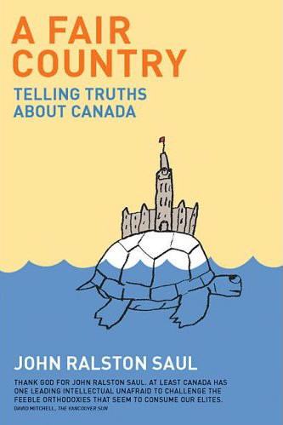
Chapter 1: What shaped us

We are a métis civilization.
What we are today has been inspired as much by four centuries of life with the indigenous civilizations as by four centuries of immigration. Perhaps more. Today we are the outcome of that experience. As have Métis people, Canadians in general have been heavily influenced andshaped by the First Nations. We still are. We increasingly are. This influencing, this shaping is deep within us.
When I dig around in the roots of how we imagine ourselves, how we govern, how we live together in communities—how we treat one another when we are not being stupid—what I find is deeply Aboriginal. Whatever our family tree may look like, our intuitions and common sense as a civilization are more Aboriginal than European or African or Asian, even though we have created elaborate theatrical screens of language, reference and mythology to misrepresent ourselves to ourselves.
Our leaders endlessly mull over our institutional and cultural inheritance from British parliamentary democracy, British and French justice, the Enlightenment, British liberalism, Western individualism with its important variations, U.S. populism, Judeo-Christian moral questioning, Athenian principles of citizenship and democracy, Western European philosophy, Western social democracy, Western capitalism, in particular its U.S. form. Frankly, once you get below the surface, I see very little in the way we use all of these that would ring familiar bells in Britain, France or elsewhere in Europe or in the United States.
Then, as if to offset all of these efforts made to conform intellectually, emotionally and structurally to the Western canon of ideas and actions, we set aside some time to praise ourselves for the great mix of cultures with which we so comfortably live. We point out that our friends and allies around the world are having trouble with similar situations. This talent, we seem to be saying, for living comfortably with diversity, is our particular contribution to Western Civilization. Yet we never seriously asked ourselves how that came to be.After all, if our civilization has been built out of the Western inheritance, how is it that the rest of the West is struggling precisely where we find the challenges quite easy?
Stranger still, in this process of examining our Western inheritance, and vaunting it, there is scarcely a nod, let alone a meaningful nod, in the direction of the First Nations, the Métis, the Inuit. There is no intellectual, ethical or emotional engagement with what their place might be at the core of our civilization. On the single issue of immigration and citizenship diversity, we seem unable to notice the obvious—that it is a non-racial idea of civilization, and non-linear, even non-rational. It is based on the idea of an inclusive circle that expands and gradually adapts as new people join us. This is not a Western or European concept. It comes straight from Aboriginal culture. But then, why bother to invoke the First Nations idea of the circle as a concept of inclusivity when you can fall back on Kant or John Stuart Mill? At best we manage a pro forma phrase about Aboriginals as one of our founding peoples.
Of course, we do worry about their situation from time to time; that is, we feel sympathy for them, particularly their children, some guilt about them, them over there, outside of our lives in small, isolated, unsustainable communities, usually reserves, or the poorest parts of our cities. But then we remind ourselves that these difficulties, even tragedies, are all caught up in complex negotiations involving civil servants and lawyers over money and land—land most of us have never seen, will never see. We are careful not to ask ourselves whether those indigenous people over there want our sympathy or are interested in our guilt.We don’t ask ourselves whether sympathy and guilt are appropriate reactions. Of course, the Canadian government was right to apologize in 2008 for the destructive residential school system. It should and could have done it in the 1980s or 1990s. And Canadians were right to believe that the apology should be made. It was an act of dignity as befits an adult nation. Yet we don’t seem to find it odd that non Aboriginals concentrate, when it comes to Aboriginals, only on what doesn’t seem to work, so that we have no idea what or how much does work or how well. As Sandra Laronde of Red Sky Theatre puts it, “We are more than our issues.”
Perhaps sympathy and guilt are inappropriate and paternalistic and insulting. Perhaps our sympathy is just a cleaned-up version of the old racist attitudes.
Perhaps those people, those Aboriginals, aren’t over there at all because we ourselves are in the same place. Perhaps in some way or many ways, we also are Aboriginal. I don’t mean in any legal sense. Perhaps the sympathy and guilt expressed toward Aboriginals are actually signs of non-Aboriginal self-denial—the sort of denial that makes us dysfunctional because we cannot embrace who we are. In colonial terms, this sort of denial is an expression of self-loathing.
And so through a maze of what non-Aboriginals believe to be problems, failures, poverty, communities out of sync with our urban view of ourselves, we see them over there, as we have for a century. We see them insisting on old treaties and bad land, which we forget that we made sure they signed and lived on. And when that land turns out to involve oil or some other wealth, we use every legal and administrative tool available to limit their ability to benefit from it. How could they possibly benefit, being such failures? Lost in this maze we cannot see how much of what we are is them, how much of what we think of as our way, our values, our collective unconscious, is dependent on what we slowly absorbed living with them or near them over the centuries.
Throughout the Western world in the second half of the nineteenth century, middle-class, pew-chained and empire-obsessed civilizations gradually slipped toward the paranoid fears of the twentieth century. Fear of what? Fear of the loss of purity—pure blood, pure race, pure national traits and values and ties. This delusionary indulgence in a purity that had never existed went further in some places than in others. But it flowered everywhere, and gradually, from the late eighteenth century on, it led to an infantile rewriting of history as one of singular peoples—singular and exceptional. These singular peoples were therefore exempted from ethical principles when it came to dealing with impurity, that is, with people not of their pure clan. Even that proved an impossible challenge, given the reality of racial impurity. And so children of the Enlightenment around the world wrapped themselves in the psycho-sexual pleasures of fear. They turned their back on the central premise of humanist philosophy and set about fearing the other, then killing the other in a multitude of ways. The mixing of the Enlightenment and nationalism throughout the Western-dominated nineteenth century produced something that swelled like a planetary boil, because a handful of empires dominated everywhere. And then we lanced it in a killing frenzy of two world wars followed by a multitude of localized but equally violent clashes.
Was there a particularity to Canada’s participation in this experience? Behind the fears of Protestants versus Catholics, English-speaking versus French-speaking, those who imagined themselves as pink or white versus all of those Ukrainians and Jews and Chinese and Japanese, was there a deeper, unspoken fear? Did those Canadians who had got hold of so much of the country—both physical and mythological—fear above all the possibility of a real other whose place this was and in whose shadow they—and eventually we—would have to find our reality? In spite of the posturing and myth manufacturing of those who dominated for approximately one century out of our four, perhaps that real other, the Aboriginal, was as present as ever, with us, within us. And were we not so much one of those singular European races, but something quite different? Perhaps the other we denied and feared was actually the possibility of becoming something more complex, an integral part of that other.
So it is both curious and troubling that we cannot bring ourselves to talk about how profoundly our society has been shaped over four centuries in its non-monolithic, non-European manner by the First Nations. Our immigrant society was fragile, tiny and poor everywhere in Canada until well into the nineteenth century. This was true even of the concentrated older enclaves of francophones and anglophones in the Maritimes and the Canadas, people who had long before stopped thinking of themselves as immigrants. In some areas it was still fragile late into the nineteenth, even into the twentieth, century. In part because of this reality, the relationship between the First Nations and the immigrants varied from region to region. And so the new Canadians, even those who had been here for two or three centuries, were in different ways still dependent on the First Nations for their survival.
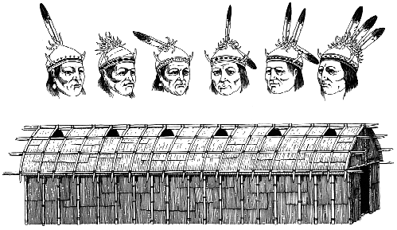
Over the first two hundred and fifty years of settler life in Canada, the newcomers had at best reached the level of partnership with the Aboriginals. New France, the Hudson’s Bay Company and the North West Company consciously built their place here on the indigenous ideas of mutual dependency and partnership. The Loyalists were part of that process. In more northerly parts of the country, that general idea of partnership went on well into the twentieth century. In the Arctic, our mixture of dependency and partnership was never completely extinguished. And already the Inuit are more or less back in control.

In what ways have Aboriginal peoples contributed
to the early development of liberalism?

(you may also want to read p.116 and pages 304-306 in the textbook)

Think back to your criteria for historical significance. Why do you think the following historical events (Enlightenment [Age of Reason], French Revolution, American Revolution, industrial Revolution) are significant in the context f classical liberalism and democracy? Use the textbook, and your recollections from social 20-1, to explain the significance of the events in the context of classical liberalism.

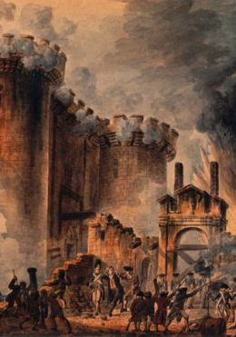

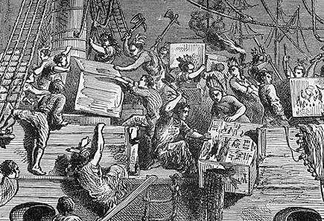

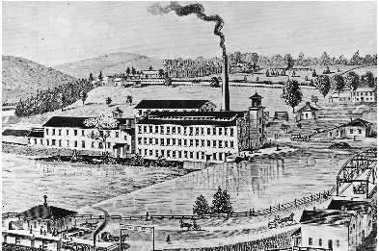

Use the information below to help you explain the most fundamental
differences between classical liberalism and modern liberalism.

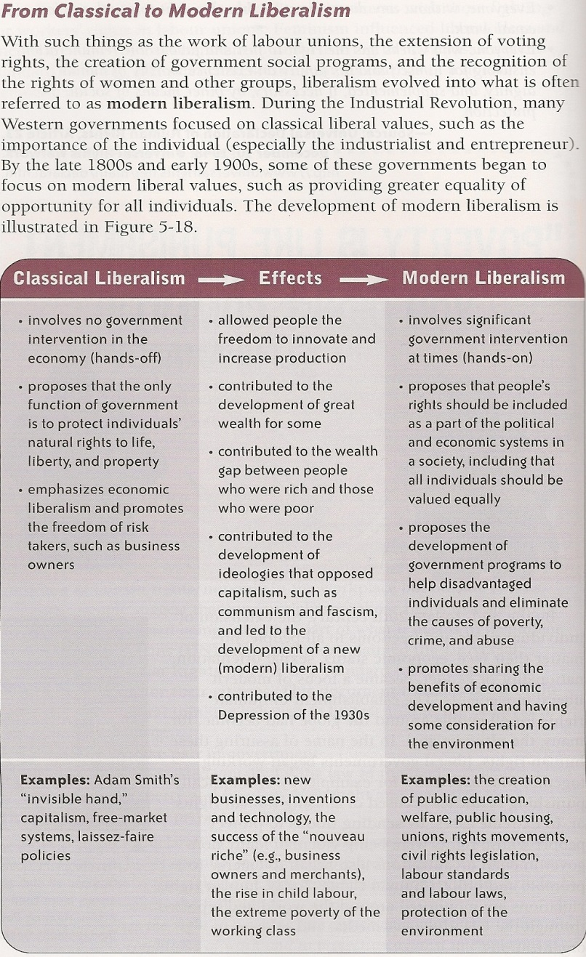
What Is Classical Liberalism? By John C. Goodman

Prior to the 20th century, classical liberalism was the dominant political philosophy in the United States. It was the political philosophy of Thomas Jefferson and the signers of the Declaration of Independence and it permeates the Declaration of Independence, the Constitution, the Federalist Papers and many other documents produced by the people who created the American system of government. Many of the emancipationists who opposed slavery were essentially classical liberals, as were the suffragettes, who fought for equal rights for women.
Basically, classical liberalism is the belief in liberty. Even today, one of the clearest statements of this philosophy is found in Jefferson's Declaration of Independence. At that time, as is the case today, most people believed that rights came from government. People thought they only had such rights as government elected to give them. But following the British philosopher John Locke, Jefferson argued that it's the other way around. People have rights apart from government, as part of their nature. Further, people can form governments and dissolve them. The only legitimate purpose of government is to protect these rights.
People who call themselves classical liberals today tend to have the basic view of rights and role of government that Jefferson and his contemporaries had. Moreover, they do not tend to make any important distinction between economic liberties and civil liberties.
On the left of the political spectrum, things are more complicated. The major difference between 19th century liberals and 20th century liberals is that the former believed in economic liberties and the latter did not. Twentieth century liberals believed that it is not a violation of any fundamental right for government to regulate where people work, when they work, the wages they work for, what they can buy, what they can sell, the price they can sell it for, etc. In the economic sphere, then, almost anything goes.
At the same time, 20th century liberals continued to be influenced by the 19th century liberalism's belief in and respect for civil liberties. In fact, as the last century progressed, liberal support for civil liberties grew and groups like the American Civil Liberties Union (ACLU) began to proudly claim the label "civil libertarian." Since liberalism was the dominant twentieth century ideology, public policy tended to reflect its beliefs. By the end of the century, people had far fewer economic rights than they had at the beginning. But they had more civil rights.
http://www.ncpa.org/pdfs/whatisclassicalliberalism.pdf

